|  |
| --- |
|  |
| Sensory Guide |
| A guide intended to make it easier for parents to plan activities for children on the autism spectrum, by providing insight on how sensory processing issues may be affected. |
|  |
|  |
|  |

|  |
| --- |
|  |
| *Disclaimer: The assessors believe the information in this assessment report to be correct at the time of printing. The assessors do not accept responsibility for any consequences arising from the use of this information. This should not be relied upon as an exhaustive record of all possible risks or hazards that may exist or potential improvements that can be made.* |



**Wax Figure Experiences**

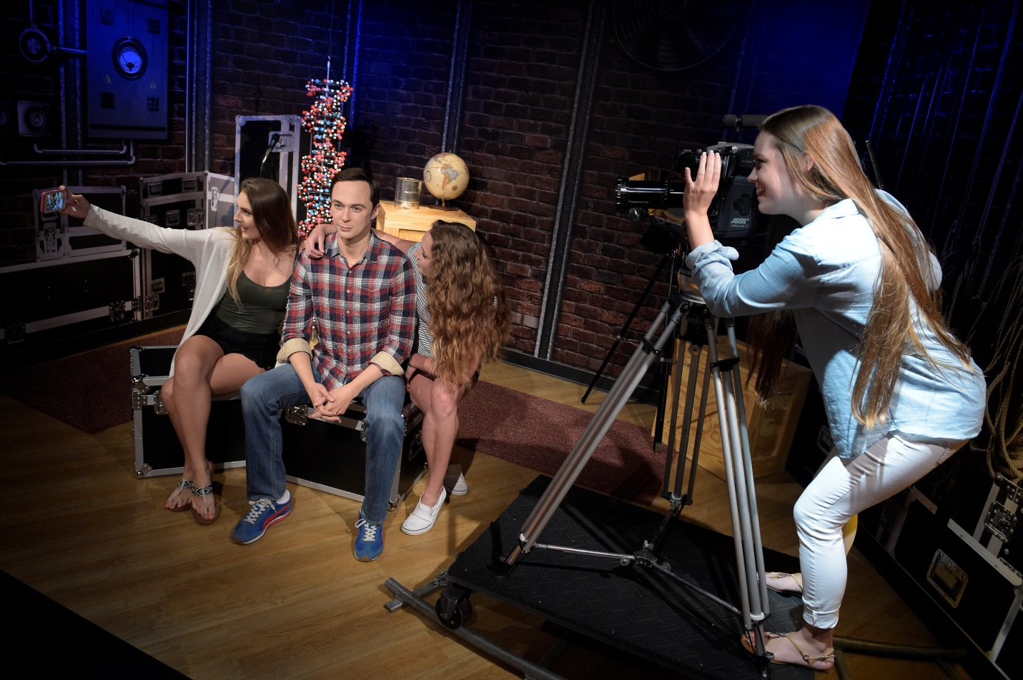

C:\Users\BNowak\Desktop\eye-open.png

**Photo / Pitbull Party Yacht**

After buying your ticket you can choose to purchase a Madame Tussauds guidebook with fun facts on our figures. Next is the photo experience, which is optional. After that, you’ll walk past the green screen and see Pitbull on his Miami yacht!

* Pitbull
* You’ll have the chance to get your family photo taken, but all photos are optional and you can bypass at any time.
* You can touch and hug our figures, but be careful not to hurt them by pushing or hitting them.
* The music in the room will be some of Pitbull’s most famous songs!

Sensory Level *(1= low sensory stimulation, 5= high sensory stimulation)*

Figures to Check Out

Guest Guidelines*/*Tips

3

1

3

1

2

SIGHT

SMELL

SOUND

TASTE

TOUCH







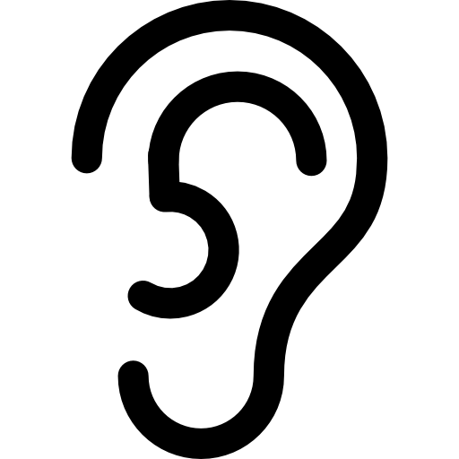





**Madame Tussauds Orlando Sensory Guide**

C:\Users\BNowak\Desktop\eye-open.png

**Ponce de Leon Room**

This is a room that looks like it’s a boat with low lighting. There’s a cannon, a captain’s wheel, bench seating for the crew, and Ponce de Leon himself! Let’s learn about how Florida was founded!

* Juan Ponce de Leon

Sensory Level *(1= low sensory stimulation, 5= high sensory stimulation)*

Figures to Check Out

Guest Guidelines*/*Tips

4

1

3

1

4

SIGHT

SMELL

SOUND

TASTE

TOUCH













**Madame Tussauds Orlando Sensory Guide**

* You can touch and hug our figures, but be careful not to hurt them by pushing or hitting them.
* There will be interesting facts that light up the floor so that you can learn more about the man who found Florida!
* There’s realistic lighting of the ship window’s shadows that brings you further into the world.
* Ponce’s wheel can spin so that you can feel like you’re captaining a ship and so that you can learn more fun facts about the Ponce and the founding of Florida.
* **Warning:** There is a cannon sound that will go off as guests pass into the room.

C:\Users\BNowak\Desktop\eye-open.png

**American History Room**

Walk through history with Uncle Sam’s efforts in the War of 1812 and Lincoln’s efforts during the Civil War. Uncle Sam and George Washington are standing figures, and Lincoln is sitting in the Ford Theater.

* Uncle Sam
* George Washington
* Abraham Lincoln
* You can touch and hug our figures, but be careful not to hurt them by pushing or hitting them.
* There will be very low levels of war music in the background.
* There are two different scenes in this room from Uncle Sam to George Washington and Abe Lincoln. The effect may be a bit jarring but the colors are all neutrals and more calming.

Sensory Level *(1= low sensory stimulation, 5= high sensory stimulation)*

Figures to Check Out

Guest Guidelines*/*Tips

5

1

3

1

3

SIGHT

SMELL

SOUND

TASTE

TOUCH













**Madame Tussauds Orlando Sensory Guide**

C:\Users\BNowak\Desktop\eye-open.png

**Neil Armstrong Room**

The room is split in half. Half looks like the moon and Neil Armstrong is in his space suit and has landed! The other half looks like a 1960’s living room with an old TV to let you feel just like everyone in the world did when Armstrong landed.

* Neil Armstrong
* You can touch and hug our figures, but be careful not to hurt them by pushing or hitting them.
* First you’ll walk from Abe Lincoln’s theater into the 1960’s living room where you’ll see Neil Armstrong next to you and you can join him on the moon.
* Listen to Neil Armstrong as he lands on the moon for the first time!
* See yourself on the TV like the people did in the 1960’s when Armstrong landed.

Sensory Level *(1= low sensory stimulation, 5= high sensory stimulation)*

Figures to Check Out

Guest Guidelines*/*Tips

5

1

3

1

3

SIGHT

SMELL

SOUND

TASTE

TOUCH













**Madame Tussauds Orlando Sensory Guide**

C:\Users\BNowak\Desktop\eye-open.png

**Oval Office**

Walk into the oval office and experience the opportunity to sit behind the desk of the President of the United States! Then, you can see President Obama near the Washington Monument.

* Donald Trump
* Barack Obama
* You can touch and hug our figures, but be careful not to hurt them by pushing or hitting them.
* Sit back in the comfy chair of the president and pose.
* Jump up and join Obama at the Washington Monument.
* The colors are mostly off white and yellow, and very light. There is little to no sound in this room, other than what you can hear from neighboring rooms.

Sensory Level *(1= low sensory stimulation, 5= high sensory stimulation)*

Figures to Check Out

Guest Guidelines*/*Tips

2

1

1

1

3

SIGHT

SMELL

SOUND

TASTE

TOUCH













**Madame Tussauds Orlando Sensory Guide**

C:\Users\BNowak\Desktop\eye-open.png

**Culture**

Speed through history with a flair for fun! First you’ll wave with MLK Jr, and then you can sit with Disney and play in his workshop. Afterwards, you’ll meet our favorite geniuses! Einstein is in his study and Edison is working in his lab playing with electricity. Finally you’ll find our modern masterminds – Warhol is posing with his art and Steve Jobs with his tech.

* Martin Luther King Jr.
* Walt Disney
* Albert Einstein
* Thomas Edison
* Steve Jobs
* Andy Warhol

Sensory Level *(1= low sensory stimulation, 5= high sensory stimulation)*

Figures to Check Out

Guest Guidelines*/*Tips

5

1

3

1

5

SIGHT

SMELL

SOUND

TASTE

TOUCH













**Madame Tussauds Orlando Sensory Guide**

* There is a lot of visual stimulation and interactives in this room. Almost every figure has either props or a game to play to learn more about them, but all props/games are optional.
* You can touch and hug our figures, but be careful not to hurt them by pushing or hitting them.
* Einstein has an intelligence test with fun facts that test your IQ.
* Edison has a game that works like operation with buzzing sounds if you hit the sides as you move a handle through a cable to understand electricity.
* **Warning:** Warhol’s TV visual is essentially a colorful mirror and can be a bit jarring for those who are more sensitive to colors.

C:\Users\BNowak\Desktop\eye-open.png

**Madame Marie Tussaud/Wax Hands Room**

Walk in and meet the famous Marie Tussaud herself. In this room, you’ll learn about how she created the brand that Madame Tussauds has become today. There’s an open theater in the corner ahead when you first walk in where you can watch a video about the history of her life. Finally, the wax hands experience is on your right when entering.

* Marie Tussaud
* You can touch and hug our figures, but be careful not to hurt them by pushing or hitting them.
* Madame Tussaud has her name on the table in a fun light for you to take pictures with.
* You can walk into the small theater area and watch a history of Madame Tussaud’s life.
* **Warning**: You see wax figures in various stages of development from the metal skeleton to the wax head with and without paint. It may be a bit jarring to see the figures look like that.
* **Warning**: Our wax hands exhibit is an option add-on experience. Guests who participate will be subject to extreme hot and cold temperatures, as well as touch sensations.

Sensory Level *(1= low sensory stimulation, 5= high sensory stimulation)*

Figures to Check Out

Guest Guidelines*/*Tips

5

1

1

1

1

SIGHT

SMELL

SOUND

TASTE

TOUCH













**Madame Tussauds Orlando Sensory Guide**

C:\Users\BNowak\Desktop\eye-open.png

**Sports**

Walk into the set of various American sports! First, you’ll see David Beckham straight ahead with Dale Earnhardt Jr. and Muhammed Ali to the right. Next, Serena Williams will be on the right with Shaq and Neymar Jr., while Dan Marino and Peyton Manning are both on the football field. Finally, you’ll see Tiger Woods on the golf course with Derek Jeter batting around the corner.

* You can touch and hug our figures, but be careful not to hurt them by pushing or hitting them.
* There are so many ways to interact with the figures in this room, and each interaction with props is optional for those interested.
* **Warning:** The game next to Muhammed Ali won’t have sound but can be very visually stimulating with the red color moving between the buttons, hence the 4 rating for sight.

Sensory Level *(1= low sensory stimulation, 5= high sensory stimulation)*

Figures to Check Out

Guest Guidelines*/*Tips

4

1

3

1

5

SIGHT

SMELL

SOUND

TASTE

TOUCH













**Madame Tussauds Orlando Sensory Guide**

* Shaquille O’Neal
* Peyton Manning
* Dan Marino
* Tiger Woods
* Derek Jeter
* David Beckham
* Dale Earnhardt Jr.
* Evander Holyfield
* Muhammad Ali
* Neymar, Jr.
* Serena Williams

C:\Users\BNowak\Desktop\eye-open.png

**Music**

Meet your favorite pop stars and get the opportunity to take a red carpet selfie with them! This room is set up as one large, open space with figures scattered throughout it. There’s everyone from Maluma to Beyoncé to Taylor Swift. There are three screens throughout the room with different videos and assorted props for the best pictures.

* This is our most visually stimulating room. There are a lot of figures grouped together, thus there will be a lot of families in this area and each figure has an interactive that can be distracting.
* You can touch and hug our figures, but be careful not to hurt them by pushing or hitting them.
* **Warning:** Music videos will play on the small screens behind Ariana Grande, Maluma, and Taylor Swift. If you push the buttons on the walls nearby the monitors, then the music will play as well.

Sensory Level *(1= low sensory stimulation, 5= high sensory stimulation)*

Figures to Check Out

Guest Guidelines*/*Tips

5

1

5

1

3

SIGHT

SMELL

SOUND

TASTE

TOUCH













**Madame Tussauds Orlando Sensory Guide**

* Beyoncé
* Harry Styles
* Selena Gomez
* Maluma
* Ariana Grande
* Bad Bunny
* Taylor Swift
* Elvis
* Michael Jackson
* Miley Cyrus

C:\Users\BNowak\Desktop\eye-open.png

**TV**

Ever since the golden age of TV in the 1960’s, we all love our TV shows! After passing Lady Gaga and Whoopi Goldberg, you’ll walk past Jimmy Fallon’s desk on the right. Then, you’ll see Oprah on the left with Katy Perry. Across from him, you’ll see Neil Patrick Harris as ‘Barney Stinson’ and Sofia Vergara before ending with Jim Parsons on the left.

* You can touch and hug our figures, but be careful not to hurt them by pushing or hitting them.
* Each set was designed to look like a part of the TV show that it comes from, so have fun jumping behind the lens on the camera!
* **Tip:** Pictures at the desk with Jimmy Fallon or behind the camera with Jim Parsons look fantastic if you have one of the guest experience staff members take the picture from farther away.

Sensory Level *(1= low sensory stimulation, 5= high sensory stimulation)*

Figures to Check Out

Guest Guidelines*/*Tips

3

1

3

1

3

SIGHT

SMELL

SOUND

TASTE

TOUCH













**Madame Tussauds Orlando Sensory Guide**

* Jimmy Fallon
* Oprah
* Neil Patrick Harris as ‘Barney Stinson’
* Katy Perry
* Sofia Vergara
* Jim Parsons

C:\Users\BNowak\Desktop\eye-open.png

**Justice League: A Call for Heroes**

HEROES UNITE! The Justice League have swooped into Madame Tussauds Orlando and they need YOUR to help save the world. Wield the power of Wonder Woman’s wrist gauntlets, help Superman lift a REAL helicopter, and act fast to summon Batman into battle!

* The Flash
* Wonder Woman
* Cyborg
* Superman
* Batman
* Aquaman

Sensory Level *(1= low sensory stimulation, 5= high sensory stimulation)*

Figures to Check Out

Guest Guidelines*/*Tips

5

1

3

1

5

SIGHT

SMELL

SOUND

TASTE

TOUCH













**Madame Tussauds Orlando Sensory Guide**

* You can touch and hug our figures, but be careful not to hurt them by pushing or hitting them.
* Walk straight onto the streets of Gotham City and Metropolis and experience life with superheroes by helping them save the world.
* First you’ll watch the newscaster’s video with Batman about the crisis in A Call for Heroes.
* **Warning:** The video to enter the Justice League: A Call for Heroes is very visually stimulating. Also, the realness of the experience can be a bit jarring.
* **Tips:** Flash – Run alongside the Flash to run at lightning speed.Wonder Woman – hold her pose next to her for the building to explode behind you. Cyborg –Find the secret code to harness the power of technology. Superman –you get to lift a real helicopter to help Superman save the day. Batman – if you move the Bat signal, you’ll see how Batman arrives in battle. Aquaman – touch the trident to summon the power of the seas!
* **Warning:** Each hero has an effect with varied sounds and lighting when you do the tasks above

C:\Users\BNowak\Desktop\eye-open.png

**Movies**

From Breakfast at Tiffany’s to Shrek to the Hunger Games, you can see it all here! The first few people you’ll see are Shrek and Fiona as well as Audrey Hepburn across from them. Then, on the left you’ll see Jackie Chan and Danny with Sandy from Grease. Next to them is Dwayne “The Rock” Johnson in his movie set. Ahead is Steven Spielberg with E.T. and on the right are Kung Fu Panda and Katniss from the Hunger Games.

* You can touch and hug our figures, but be careful not to hurt them by pushing or hitting them.
* Each setting is very different, so make sure to be careful with the figures and sets.
* **Warning:** Dwayne “The Rock” Johnson’s set features loud music with heavy AV elements including lighting. Guests have the option to take a picture without these elements by not pushing the button before entering his space.
* **Tip:** For the E.T. photo, the best one is if you ride the bike!

Sensory Level *(1= low sensory stimulation, 5= high sensory stimulation)*

Figures to Check Out

Guest Guidelines*/*Tips

5

1

4

1

5

SIGHT

SMELL

SOUND

TASTE

TOUCH













**Madame Tussauds Orlando Sensory Guide**

* Steven Spielberg
* E.T.
* Katniss Everdeen
* Shawn Mendes
* Audrey Hepburn
* Shrek and Fiona
* Danny and Sandy (Grease)
* Jackie Chan
* Dwayne “The Rock” Johnson
* Kung Fu Panda



C:\Users\BNowak\Desktop\eye-open.png

**A-List Party**

OMG it’s the paparazzi! No, wait, it’s just our new VIP guests. First, you’ll walk into a hallway with Channing Tatum and red Corvette. Then, you’ll walk into an open layout room, similar to the music room, where you can dress up and take pictures with your favorite celebrities!

* You can touch and hug our figures, but be careful not to hurt them by pushing or hitting them.
* The lighting is lower in this room than any of the others, and there is seating for any guest that needs it.
  + There will also be revolving lights around the room in various shapes and sizes.

Sensory Level *(1= low sensory stimulation, 5= high sensory stimulation)*

Figures to Check Out

Guest Guidelines*/*Tips

5

1

3

1

2

SIGHT

SMELL

SOUND

TASTE

TOUCH













**Madame Tussauds Orlando Sensory Guide**

* Brad Pitt
* Angelina Jolie
* Anne Hathaway
* Emma Watson
* Ryan Gosling
* Leonardo DiCaprio
* Awkwafina
* Channing Tatum
* Jennifer Lopez
* Zendaya
* Ryan Reynolds
* Johnny Depp
* Samuel L Jackson
* Tom Hanks